User Log In

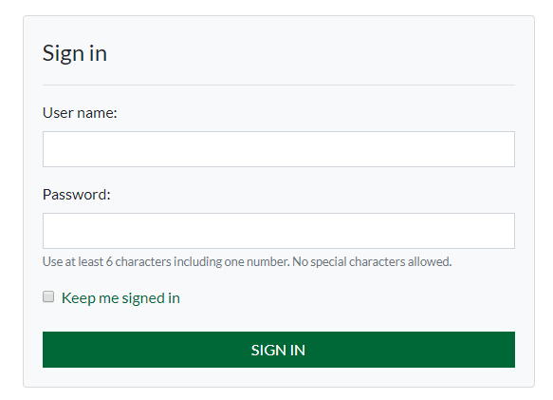

User Creates a account for an existing company

Tables

* dbo.ECOM_CUSTOMERSUSER
* dbo.ECOM_CUSTOMERTYPE
* dbo.ECOM_CUSTOMERUSERFUNCTION
* dbo.CUSTOMER

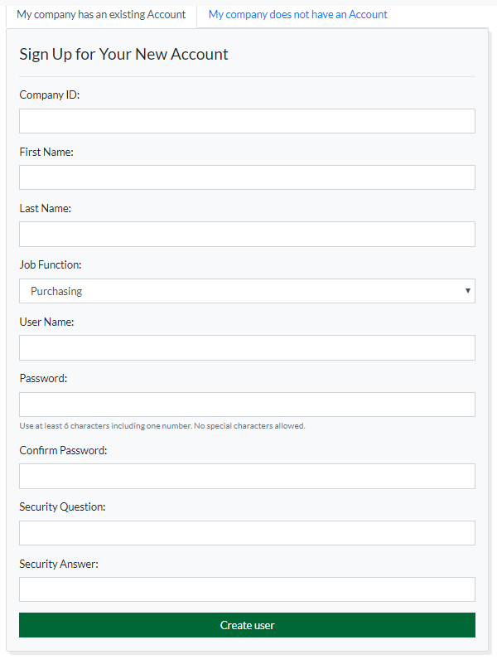

User creates an account for a new company

* dbo.ECOM_CUSTOMERSUSER
* dbo.ECOM_CUSTOMERTYPE
* dbo.ECOM_CUSTOMERUSERFUNCTION
* dbo.CUSTOMER
* dbo.CUSTOMERBILLTOADDRESS
* dbo.ECOM_CUSTOMERSHIPADDRESS
* dbo.CUSTOMERCREDITCARD

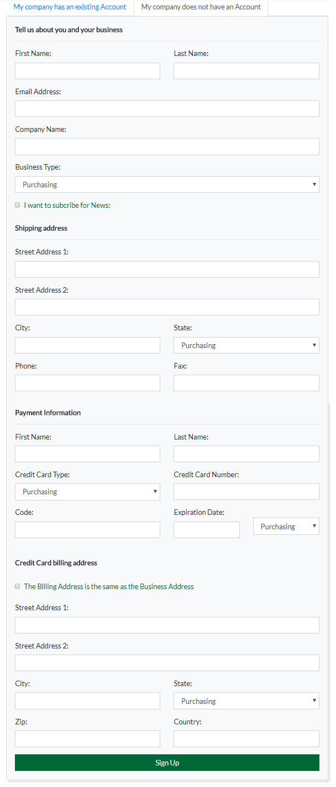

**Forgot Password**

**Recover password**